**Birla Institute of Technology & Science, Pilani**

**Work Integrated Learning Programmes Division**

**Second Semester 2021-2022**

**Mid-Semester Test**

**(EC-2 Regular)**

# Course No. : SE ZG651

Course Title : Software Architectures

Nature of Exam : Open Book

Weightage : 30

No. of Pages =

# No. of Questions = 4

Duration : 2 Hours

Date of Exam : 12/03/2022 (FN)

Note to Students:

1. Please follow all the *Instructions to Candidates* given on the cover page of the answer book.
2. All parts of a question should be answered consecutively. Each answer should start from a fresh page.
3. Assumptions made if any, should be stated clearly at the beginning of your answer.
4. 8 Marks

You are developing a project to design the University management system for a startup anonymous autonomous University for their Engineering stream with 1500 students and 75 faculty. This system supports the following features and functions:

• Automated attendance of students and teachers, using fingerprint scanner.

• Ability to post course materials, assignments on a course page by the faculty and students submit the solution.

• Integration with the other streams i.e., Arts and Science, Medicine etc.

• Ability to post announcements.

• Ability to upload the overall student wise and class wise grades for each course

• Ability to access via mobile as well as desktop.

a) State 3 ASRs? Justify. (3)

b) Define the primary tactics you will use to satisfy these quality attributes. (3)

c) Briefly explain the strategies to protect how intruders would be protected from exporting important files through mail or Google drive. (2)

1. . 8 Marks

You are developing a project to design the University management system for a startup anonymous autonomous University for their Engineering stream with 1500 students and 75 faculty. This system supports the following features and functions:

• Automated attendance of students and teachers, using fingerprint scanner

• Ability to post course materials, assignments on a course page by the faculty and students submit the solution.

• Integration with the other streams like Arts and Science, Medicine etc... for example.

• Ability to post announcements

• Ability to upload the overall student wise and class wise grades for each course

• Ability to access via mobile as well as desktop

a) State 3 ASRs? Justify. (3)

b) Define the term tactics as applied to dealing with quality attributes. Is there consideration of tradeoffs while a tactic is being considered during design phase? Answer in the context of the case given above. (3)

c) Define maximum three points that define a "Good Architecture" in the context of the case given above. (2)

1. . 8 Marks

You are developing a project to design the University management system for a startup anonymous autonomous University for their Engineering stream with 1500 students and 75 faculty. This system supports the following features and functions:

• Automated attendance of students and teachers, using finger print scanner

• Ability to post course materials, assignments on a course page by the faculty and students submit the solution.

• Integration with the other streams like Arts and Science, Medicine etc... for example.

• Ability to post announcements

• Ability to upload the overall studentwise and classwise grades etc...for each course

• Ability to access via mobile as well as desktop

a) State 3 ASRs? Justify. (3)

b) Define the primary tactics you will use to satisfy these quality attributes. (3)

c) Identify two software quality attributes that can be traded off at the expense of other Point exactly the logic with good reasoning (2)

1. 8 Marks

A Plastic manufacturing unit manufactures plastic sleeves of various dimensions as per its clients’ needs. The company mail server accepts emails from off-line and on-line clients periodically during runtime. The mail is to be delivered to other mail servers on the network, many of which fail to be delivered because the target server cannot be located. Each mail is either delivered or fails to be delivered for various reasons. We would like to assure that 99.9999% of emails (which are correctly addressed) are correctly delivered. The servers have to be located in the internet through an efficient system so that resources are not wasted in locating other servers resulting in lost emails.

* 1. Indicate whether the **Interoperability** quality attributeis being addressed here?Explain your answer with the **Quality attribute** and **Stimulus** being addressed here with explanation. [1+1]
  2. Sketch the general scenario indicating the six parts of quality attribute scenario. Explain the **Source** & **Stimulus** portion of scenario with their possible values. [2+1]
  3. Suggest a Tactic to resolve the issue and describe the working of the tactic. [1+2]

1. 8 Marks

A Plastic manufacturing company manufactures plastic sleeves of various dimensions as per its clients’ need. The company mail server accepts emails from off-line and on-line clients periodically during runtime. The mail is to be delivered to other mail servers on the network, many of which fail to be delivered because the target server cannot be located. Each mail is either delivered or fails to be delivered for several reasons. We would like to assure that 99.9999% of emails (which are correctly addressed) are correctly delivered. The servers have to be located in the internet through an efficient system so that resources are not wasted in locating other servers resulting in lost emails.

1. Indicate whether the **Modifiability** quality attributeis being addressed here?Explain your answer with the **Quality attribute** and **Stimulus** being addressed here with explanation. [1+1]
2. Sketch the general scenario indicating the six parts of quality attribute scenario. Explain the **Artifact** & **Environment** portion of scenario with their possible values. [2+1]
3. Suggest a Tactic to resolve the issue and describe the working of the tactic. [1+2]
4. 8 Marks

A Plastic manufacturing company manufactures plastic sleeves of various dimensions as per its clients’ need. The company mail server accepts emails from off-line and on-line clients periodically during runtime. The mail is to be delivered to other mail servers on the network, many of which fail to be delivered because the target server cannot be located. Each mail is either delivered or fails to be delivered for several reasons. We would like to assure that 99.9999% of emails (which are correctly addressed) are correctly delivered. The servers have to be located in the internet through an efficient system so that resources are not wasted in locating other servers resulting in lost emails.

1. Indicate whether the **Availability** quality attributeis being addressed here?Explain your answer with the **Quality attribute** and **Stimulus** being addressed here with explanation. [1+1]
2. Sketch the general scenario indicating the six parts of quality attribute scenario. Explain the **Response** & **Response Measure** portion of scenario with their possible values. [2+1]
3. Suggest a Tactic to resolve the issue and describe the working of the tactic. [1+2]
4. 8 Marks
   1. Assume that there is a project management software company named **Softronix**. They sell their software product globally with a monthly pay-per-user model. It is extensively recognized among the project management community because of easiness of using the software and ability of operating on many different devices such as Personal Computers, iPhones, tablets , Notebooks and Android phones.

The business problem of **Softronix** is very straightforward:

1. We know that users have different devices. So, its software product must run on any popular device on the market
2. To lower the maintenance costs, there should be only one software application
3. The software produced by the company has to support future devices so that when new device is launched, the whole software product do not require changes.

Draw a diagram to depict an architectural solution for this situation. **(4 Marks)**

* 1. “Pipe and Filter is another architectural pattern, which has independent entities called **filters** (components) which perform transformations on data and process the input they receive, and **pipes**, which serve as connectors for the stream of data being transformed, each connected to the next component in the pipeline.

Draw a diagram to depict an architectural solution for this situation. **(2 Marks)**

* 1. Assume that you have planned to construct distributed systems that can service asynchronous arriving messages associated with an event, and that can scale from small and simple to large and complex.

Draw a diagram to depict an architectural solution for this situation. **(2 Marks)**

1. 8 Marks
2. Consider the following scenario for Window Manager Systems. A window management system is a type of interactive user interface that enables users to work with multiple separate applications at the same time. This is achieved through the use of a desktop metaphor in which each process is associated with a graphical window. A window management system provides the functionality to create and manipulate the display of multiple processes. A window management system includes different important components such as

* Input manager for I/O controlling,
* Process manager for managing application processes,
* Screen manager for maintaining the integrity of the screen and
* Window manager for managing the windows that are related to the application processes.

Draw a diagram to depict an architectural solution for this situation. **(4 Marks)**

1. “Suggest an appropriate architecture for each of the descriptions below.
2. Wants a system that quickly can analyze enormous volumes of data by sorting the data and then analyzing the grouped data
3. Wants to set up a set of equal distributed computational entities that are connected via a common protocol to share their services and provide high availability and scalability.

Draw a diagram to depict an architectural solution for this situation. **(2 Marks)**

1. Assume that you have built an eBook. The eBook has some confidential data should be secured from unauthorized users. How do you use the methods Authorization, Authentication, and Nonrepudiation to secure? **(2 Marks)**
2. 8 Marks
3. Consider a system that is pictorially represented in the following diagram that desires to notice the faults in its components. You are the architect who has decided to introduce ping/echo. In this framework you are faced with 3 challenges – how to add ping/echo (modifiability), how to avoid ping flood attach (security), overhead of ping/echo (performance). You have decided to solve the performance issue on priority. Explain the approach that you will take. (Note: introduction of a tactic may produce additional challenges) **(4 Marks)**

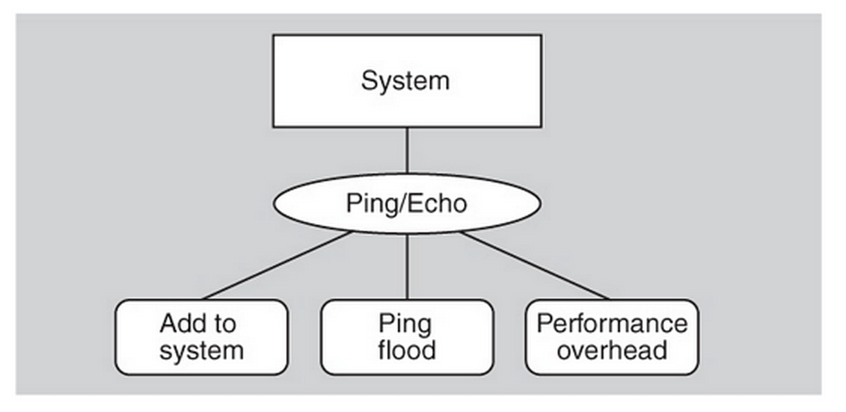

1. Compilers traditionally consist of Lexical Analyzer – Syntax Analyzer, Semantic Analyzer, Intermediate Code Generator, Code Optimizer, Target Code Generator operating one after the other. All of them refer to Symbol Tables and errors are recorded using Error Handling routines.

An architecture handling this would be viewed as a pipeline system. Draw a diagram depicting this architecture. **(2 Marks)**

1. You are developing a software application. Assume that it is expected to be accessed by a half a million users. How will you test this scenario (you can’t get so many people to sign-up to test your system!)? What testability tactics will help you to do the testing? **(2 Marks)**
2. 6 Marks

## **Relating Business Goals to Architecturally Significant Requirements for Software Systems**

The primary purpose of the architecture for a software-reliant system is to satisfy the driving behavioral and quality attribute requirements. Quality attribute requirements tend to be poorly captured and poorly represented in requirements specifications, which focus on functionality. It is often up to the architect’s own initiative to capture the actual quality attribute requirements for a system under development. Quality attributes come about because of the business goals behind the system being developed. Business goals drive the conception, creation, and evolution of software-reliant systems. This report examines business goals from the point of view of the software architect. It presents a wide survey of business goal categories from the business literature and uses that survey to produce a classification of business goals. It introduces the concept of goal-subject (the person or entity who owns the business goal) and goal-object (the person or entity that the goal is intended to benefit). Those concepts are essential to the structure of a business goal scenario—a systematic way to elicit and express business goals. Using the concept of a business goal scenario drives the Pedigreed Attribute eLicitation Method (PALM), developed by the authors for eliciting architecturally significant business goals. The report illustrates how to use architecturally significant business goals to produce a set of derived quality attribute requirements that can then be vetted and elaborated with the appropriate goal-subject(s) and goal-object(s).

Different Architects design a different solution for the same System in the same environment. Use a diagram to explain the influences on the architect and the architecture in the above context. Use reference to the above text while explaining your opinion.

1. 6 Marks

**System Architecture Virtual Integration: An Industrial Case Study**

The aerospace industry is experiencing exponential growth in the size and complexity of onboard software. It also sees a significant increase in errors and rework of that software. All those factors contribute to greater cost; the current development process is reaching the limit of affordability of building safe aircraft. An international consortium of aerospace companies with government participation has initiated the System Architecture Virtual Integration (SAVI) program, whose goal is to achieve an affordable solution through a paradigm shift of “integrate then build.” Key concepts of this paradigm shift are an architecture-centric model repository as single source for analytical system models, accessed through a model bus, used as a single source for analytical models, and multi-level, multi-fidelity analysis of multiple operational quality attributes of the system and embedded software system architecture. The result is discovery of system-level faults earlier in the life cycle—reducing risk, cost, and development time. The first phase of this program demonstrated the feasibility of this new development process through proof of concept which is the topic of this report.

Different Architects design a different solution for the same System in the same environment. Use a diagram to explain the influences on the architect and the architecture in the above context. Use reference to the above text while explaining your opinion.

1. 6 Marks

**Scenario-Based Analysis of Software Architecture**

Software architecture is one of the most important tools for designing and understanding a system, whether that system is in preliminary design, active deployment, or maintenance. Scenarios are important tools for exercising an architecture in order to gain information about a system's fitness with respect to a set of desired quality attributes. This paper presents an experiential case study illustrating the methodological use of scenarios to gain architecture-level understanding and predictive insight into large, real-world systems in various domains. A structured method for scenario-based architectural analysis is presented, using scenarios to analyze architectures with respect to achieving quality attributes. Finally, lessons and morals are presented, drawn from the growing body of experience in applying scenario-based architectural analysis techniques.

Different Architects design a different solution for the same System in the same environment. Use a diagram to explain the influences on the architect and the architecture in the above context. Use reference to the above text while explaining your opinion.